
2025.08.03
The Risø Courses on
Validation and Process Control for Electron Beam Sterilization

20 – 24 April, 2026
7 - 11 September, 2026

Risø High Dose Reference Laboratory
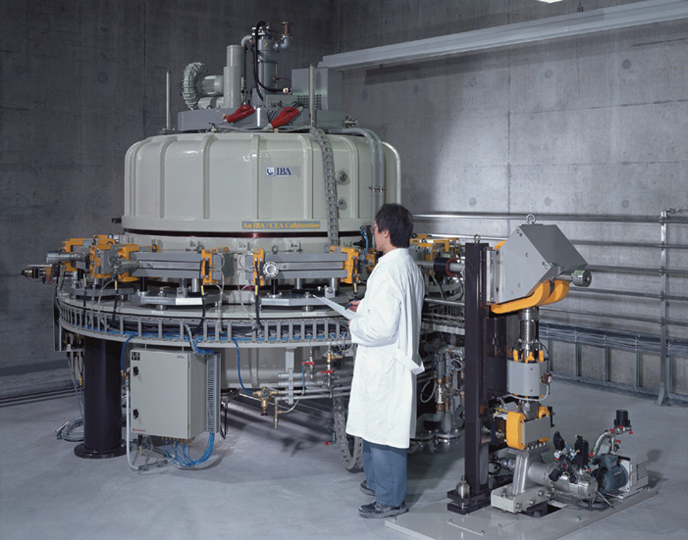
DTU Health Tech
Technical University of Denmark, Risø Campus
DK 4000 Roskilde, Denmark

The radiation sterilization process must be validated, and the dose measurements must be traceable to national standards as required by the international standard EN ISO 11137-1, “Sterilization of Health Care Products – Radiation – Requirements for Development, Validation and Routine Control of a sterilization Process for Medical Devices”.

This Risø course gives background for understanding and implementing the requirements of EN ISO 11137. The standard was recently revised, and the new ISO 11137-1:2025 will be reviewed and the impact of the differences from the old version will be highlighted.

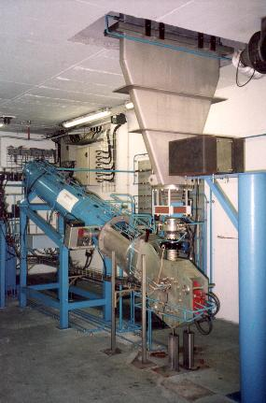
The emphasis of this course is on high energy (10 MeV) electron beam sterilization, but aspects of gamma sterilization and of low energy (100-200 keV) electron beam irradiation will also be addressed.

The focus points of the course are:
1. Calibration of dosimetry systems.
2. Determination and use of measurement uncertainty.
3. Dose measurements as required and used in:
- IQ/OQ, Installation / Operational Qualification
- PQ, Performance Qualification
- Routine monitoring and Process Control
4. Establishing the sterilization dose using the methods in EN ISO 11137-2 and EN ISO 13004.
5. Establishing maximum acceptable dose by investigating effect of dose on product.
During the dosimetry part of the course, the participants will
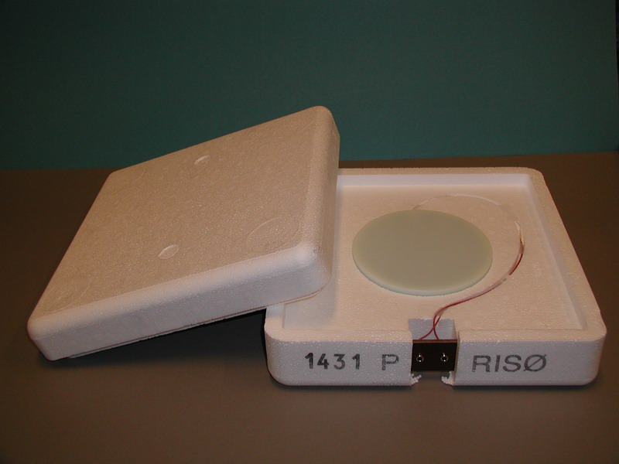
- calibrate dosimeters to be used in IQ/OQ and PQ exercises,
- carry out IQ/OQ measurements on a 10 MeV electron accelerator,
- perform PQ dose mapping studies on products,
- make routine dosimetric process control.

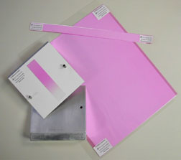
Different dosimetry systems are used during the course:
Calorimeters
Radiochromic film dosimeters
Alanine / EPR dosimeters

Methods for selecting or substantiating a sterilization dose for medical devices described in EN ISO 11137-2 and EN ISO 13004 are covered by lectures and exercises based on simulated data.
The discussion of the dose setting methods comprises:
- sterilizing dose selection - Methods 1 and 2, Methods VD_{max}²⁵ and VD_{max}¹⁵
- sterilizing dose audit
- bioburden estimation (ISO 11737-1)
- testing for sterility (ISO 11737-2)
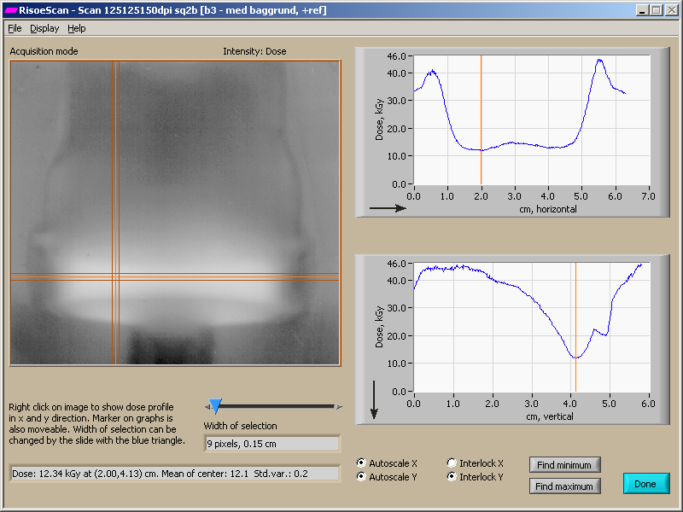

Material effects
The basis for selecting materials for products to be radiation sterilized, and for establishing a maximum acceptable dose for products will be reviewed and discussed.
The discussion will include:
- effects of irradiation on the properties of plastics.
- biocompatibility and testing for toxicity and pyrogenicity (EN ISO 10993)

Lecturers:
Arne Miller Risø High Dose Reference Laboratory
Mark Bailey Risø High Dose Reference Laboratory
Christina Ankjærgaard Risø High Dose Reference Laboratory
Eamon Hoxey E.V.Hoxey, UK
Frederik Steenstrup Technological Institute, Denmark
Andy Makin Andrew Makin Preclinical Consulting, Denmark

Experience and background
All lecturers have several years of experience as experts in their fields and as teachers at these and other courses.
Risø High Dose Reference Laboratory is accredited by Danish Accreditation according to EN ISO 17025:2017.
The course is organized in collaboration with Sterigenics, Espergærde, Denmark, who operates a 10 MeV electron accelerator for ISO-9001 certified service irradiation.

History
The Risø course has been repeated more than 60 times since we started in 1993. A total of approximately 600 participants from more than 100 companies and institutions have expressed their satisfaction with the unique mixture of theory and practical exercises.
The course is continuously being updated to follow the developments in dosimetry methods and in the international standards on radiation sterilization.

Certificate
Each participant will receive a certificate to witness participation.

Who should attend?
Persons working with different aspects of electron beam sterilization.
Quality management staff and operators at electron beam facilities.
Quality management staff at manufacturers of medical equipment.

Because of the emphasis on gaining practical dosimetric experience during the course, the number of participants is limited to 9, who will work in 3 groups.

Location
The course will be held at DTU Health Tech near Roskilde, Denmark, approximately 30 km west of Copenhagen, see: Risø Campus (dtu.dk)

Cost
The cost for one participant is DKK 38.500.- This includes:
- course compendium
- refreshments and lunches
- one dinner (Thursday evening).
Multiple attendees’ discount: Two or more participants from the same company location attending the same course together are eligible for a 10% discount on the total course fee.

Registration
Please fill in the attached registration form and send it to: armi@dtu.dk

Payment
An invoice will be sent after receipt of registration.
Payment should be made no later than one month before the start of the course.
Final registration of participants will be made in order of their payments.

The small print.
Fees are refunded in full if DTU Health Tech receives notification of a participant's cancellation at least one month before the start of the course. No refund is made for cancellations made later, or for not attending the course (no-shows). Cancellation notification must be made in writing by fax or e-mail. Substitute participants are welcome, without prior notice, should the registrant be unable to attend the course.

DTU Health Tech reserves the right to modify course material, substitute speakers without notice, or to cancel the course. If the course must be canceled, an extremely rare occurrence due to circumstances beyond our control (e.g. melting of the polar ice cap, lecturer being hospitalized, coup d'etat, etc.), registrants will be notified as soon as it is possible and will receive a full refund of fees paid. DTU Health Tech will not be responsible for discount airfare penalties or other costs incurred due to a course cancellation.
Accommodation

List of hotels in Roskilde:
Four Points Flex Four Points Flex by Sheraton Roskilde | Leisure & Business Hotel in Roskilde
Scandic Scandic Roskilde Park
Comwell https://comwell.com/hoteller/comwell-hotel-roskilde

There are plenty of hotels in and around Copenhagen, but transportation time to/from DTU Risø is longer.
Contact us if you want assistance.

Further information can be obtained from

Arne Miller
High Dose Reference Laboratory
DTU Health Tech,
Technical University of Denmark, Risø Campus
Frederiksborgvej 399
DK 4000 Roskilde
Denmark

Phone: +45 4677 4224,
Mobile: +45 2132 5613
e-mail: armi@dtu.dk
Web site: Industrial and medical dosimetry (dtu.dk)

